Magic
Spell proficiency is an option in sovereign creation. Players can select or build sovereigns with proficiency in Air, Death, Earth, Fire, Life or Water magic.
As the sovereign levels, traits can be selected that increase these proficiencies (a sovereign created as an Air Disciple can become an Air Mage).

Apprentice Access to level I spells

Disciple Access to level II spells

Mage Access to level III spells

Expert Access to level IV spells

Master Access to level V spells
Spells require a certain proficiency in their type to be used. Fireball requires the caster to be a Fire Mage to be able to cast.

Champions
Champions are similar to sovereigns in that they can have proficiency in the various types of magic. Unlike sovereigns, they are initially unable to cast spells. Before they can cast spells a sovereign has to cast Imbue Champion on them.
In the world of Elemental magic has been trapped in shards. There are only a few, called channelers, that are able to draw upon that magic. All of the games sovereigns are channelers. Although the champions of the world may have an aptitude for different types of magic, they cannot cast spells until a channeler has imbued them and allowed that champion to access the world’s magic.
Just like sovereigns champions can increase their proficiency with different types of magic as they level. Champions can learn different magic types than your sovereign.

Global Mana
Though you may have multiple casters in your empire, there is only one store of mana that they all use to power their spells. The decision to use your mana to enchant your champions, attack your enemies, move around the world or guard your cities is a critical one to surviving in the world of Elemental.
Your sovereign provides a small amount of mana each turn. But there is more to be found by building shrines on the world’s mana shards. Spells with maintenance costs like enchantments, city enchantments and summons will detract from your mana each turn.
Click on the mana symbol in the main screen to get a breakdown on where your mana is going, or to dispel enchantments you no longer need.

Shards
Shards are important because they add to the amount of mana a player earns each turn, they also improve the effect of many of the spells in the game. For example, “fireball for 6 damage (+3 per fire shard)”, means it does 6 damage for a player who doesn’t control any fire shards, 9 damage for a player that controls 1 fire shard and 15 damage for a player that controls 3 fire shards.
The world starts populated with Life shards, but if these fall into Empire territory they are automatically converted to Death shards. Taking these shards from your enemies both weakens their spells, and strengthens your own.
There is a world option that controls the frequency of shards in the world. Having more shards in the world means that players will be receiving more mana and that spells will be more powerful.

Life and Death magic
Although all players can access Air, Earth, Fire and Water spells (if they have units with the appropriate proficiency) Life spells can only be used by Kingdom allegiance players. Conversely Death spells can only be used by Empire allegiance players.

Spell Types
There are many types of spells in Fallen Enchantress. The spells type determines when it can be cast. A player can’t enchant one of his cities during a tactical battle, or curse an enemy unit from the world map.
Strategic- Strategic spells can only be cast from the world map (not while in tactical combat). In general these spells only require that the player has a single unit who can cast the spell to be able to cast the spell anywhere. If the player has a unit that can cast Tornado (the sovereign or an imbued champion) that player can cast Tornado anywhere.
Tactical- Tactical spells can only be cast in tactical combat. Unless otherwise specified the duration lasts only for that battle. If a unit is Hasted in tactical combat, it only gains that bonus for that battle.
Universal- Universal spells can be cast either in tactical combat or from the world map. Some spells have slightly different effects depending on if they are cast in tactical combat or on the world map. For example, if an Earth Elemental is summoned in tactical combat it only lasts for that battle. If an Earth Elemental is summoned on the world map then it stays with that army, but has a mana maintenance cost that must be paid each turn.
Enchantment- Enchantment spells are cast on units and can be used to make your units more powerful or protect them. Most have a mana maintenance cost.
City Enchantment- City enchantments affect cities much as enchantments affect units. They can boost the research for that city, help defend it, or provide a variety of other benefits. Most have a maintenance cost.

Overkill
Some Spells damage is multiplied by the amount of members of the victims group. If a spell like this does 3 damage it would do 3 damage to a unit with only one member in the unit (like a champion), 9 damage to a unit with 3 members (like a group of peasants) or 27 damage against a unit with 9 members (like a company of defenders).
Although these spells aren’t as effective against champions and single unit groups, they are very powerful when used against large groups of defenders. Use overkill spells like Fireball to weaken enemy armies, and high damage spells without overkill, like Touch of Entropy, against champions.

Base spells
The following spells are unlocked for all sovereigns regardless of what spell books they have.


Imbue Champion
Strategic enchantment
Enables a champion to cast spells. Unless they are imbued champions are unable to cast spells.


Paragon
Strategic
Sovereign gets -1 to Constitution, Strength and Dexterity. Target champion gains a level.

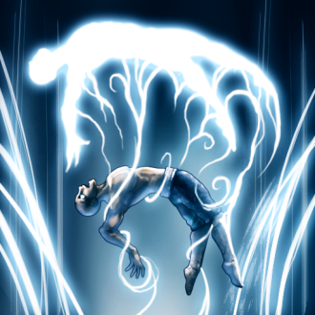
Steal Spirit
Strategic
Description: Allows a sovereign to take a spell rank from a champion, it kills the champion.


Air Spells
Air spells are available to all casters that have the required proficiency with Air magic.

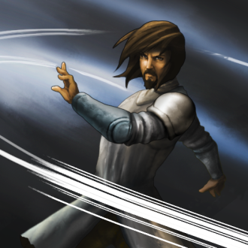
Evade
Air I
Strategic enchantment
Target unit receives +5 to Dodge (+2 per air shard).

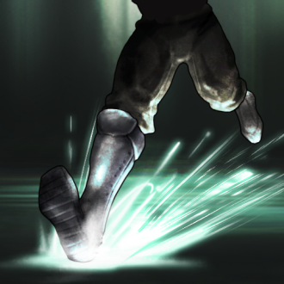
Haste
Air I
Tactical
Target unit is +2 to combat speed (+1 per air shard).


Aura of Grace
Air II
Strategic city enchantment
All units produced in this city are +3 to dexterity (+1 per air shard).

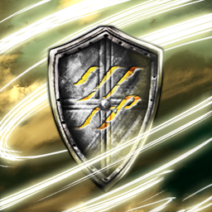
Guardian Wind
Air II
Tactical
All allies gain +10 Dodge (+5 per air shard) vs missile attacks.

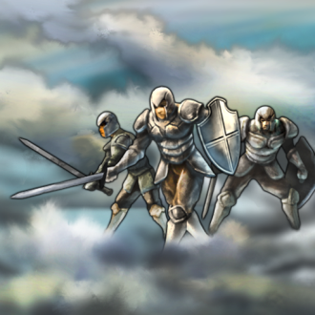
Cloud Walk
Air III
Strategic
Teleports the caster, and his army, to a tile in friendly territory.
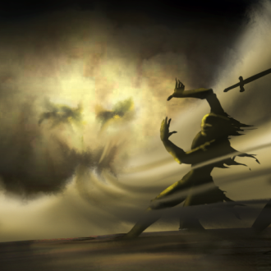
Titan’s Breath
Air III
Tactical
All enemies are blown back 1 tile, and knocked prone unless they resist.
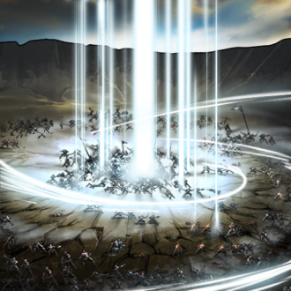
Escape
Air IV
Tactical
Allows your army to escape from combat.

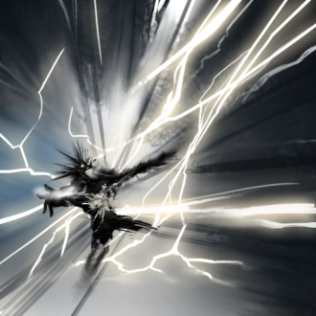
Storm
Air IV
Tactical
Lightning strikes a random enemy for 6 Lightning damage per member (+3 per air shard).
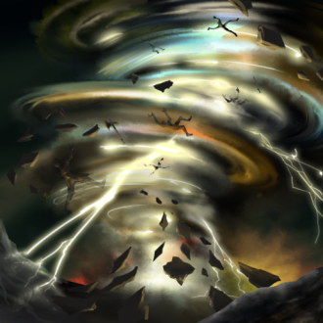
Tornado
Air V
Strategic
All units in the targeted army are randomly scattered around the surrounding tiles, are immobilized for a turn and take 3 damage per air shard.


Death Spells
Only Empire casters can learn Death spells. These spells are available to all Empire casters who have the require proficiency with Death Magic.
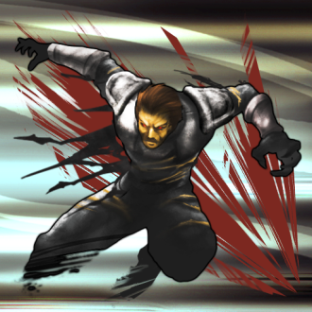
Berserk
Death I
Tactical
50% of the target units Dodge is transferred to Attack.

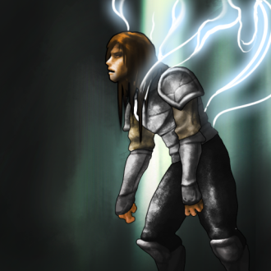
Wither
Death I
Tactical
Reduces the dexterity, strength and constitution of target unit by 5 (+2 per death shard), unless they resist.
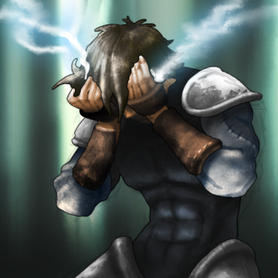
Blindness
Death II
Tactical
Target enemy is stricken blind, resulting in a 50% penalty to accuracy and dodge for 5 rounds, unless they resist.

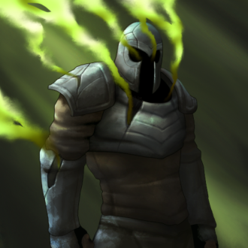
Curse
Death II
Tactical
Reduces target units Defense by 4 (+2 per death shard) unless they resist.

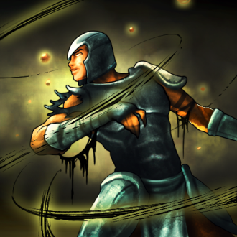
Contagion
Death III
Tactical
All enemy units take 2 poison damage (+1 per death shard) for 10 turns, unless they resist.
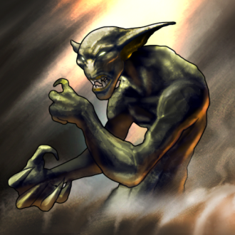
Touch of Darkness
Death III
Strategic
Demons whisper to anyone willing to listen. Doing so will improve the casters spell power, at the cost of a portion of his sanity. (+5 intelligence, -3 constitution)
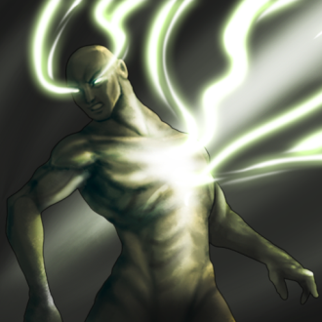
Drain Life
Death IV
Tactical
Transfers 8 hit points (+4 per death shard) from target unit to the caster. That damage is halved if the enemy resists.

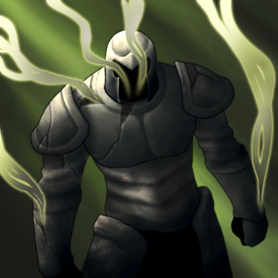
Mass Curse
Death IV
Tactical
Reduces all enemy units Defense by 4 (+2 per death shard), unless they resist.

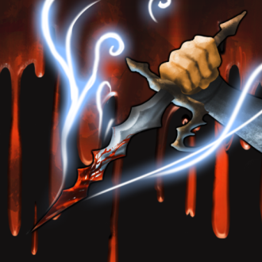
Sacrifice
Death V
Strategic
Target city you control loses half its population, you gain 1 mana per 2 population.


Earth Spells

Earth spells are available to all casters who have the required proficiency with Earth magic.
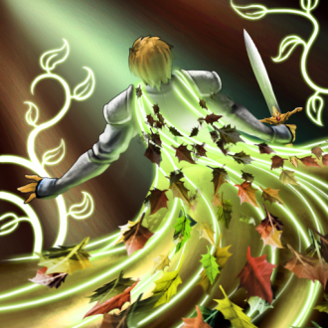
Nature’s Cloak
Earth I
Strategic enchantment
Target unit receives +5 Defense (+2 per earth shard) vs. fire, lightning and cold damage.
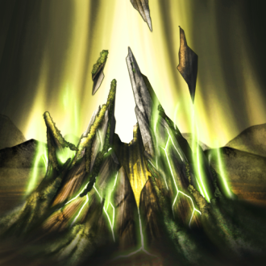
Raise Land
Earth I
Strategic
Turn water, beach and cliff into land or land into a hill.

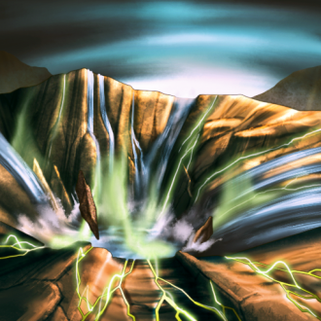
Lower Land
Earth I
Strategic
Turn a mountain into a hill or a hill into land.

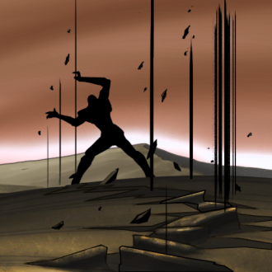
Tremor
Earth II
Strategic
Target army in your territory is immobilized for 1 turn.


Stoneskin
Earth II
Strategic enchantment
Target unit receives +3 to physical Defenses (+1 per earth shard).
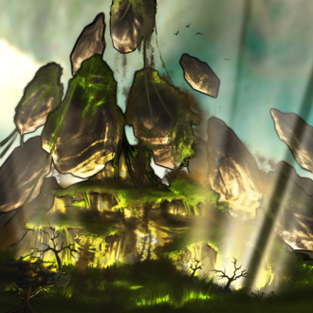
Create Mountain
Earth III
Strategic
Turns land or a hill into a mountain.

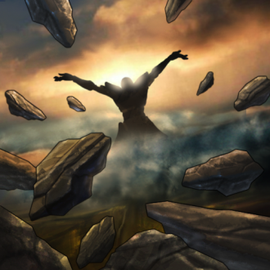
Shockwave
Earth III
Tactical
A minor earthquake damages all enemies within 1 radius of the caster for 8 (+4 per earth shard) in damage. Shockwave has a high mana cost.
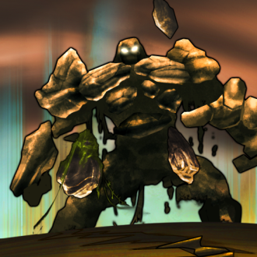
Summon Earth Elemental
Earth IV
Universal
Summons a level 4 (+1 per earth shard) Earth Elemental. If the elemental is summoned into tactical combat it lasts until the end of that combat, if the elemental is summoned from the strategic map it has a maintenance cost.
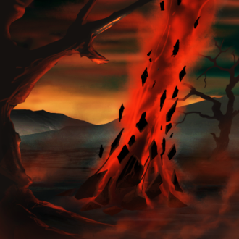
Destroy Land
Earth IV
Strategic
Plunge land or mountains directly into the depths of the sea.

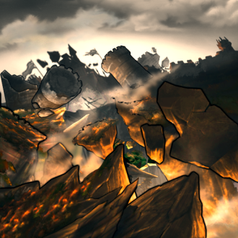
Earthquake
Earth V
Strategic
Destroys random city improvements, resets the production queue and halves the population of the targeted city.


Fire Spells
Fire spells are available to all casters who have the required proficiency with Fire magic.

Burning Blade
Fire I
Strategic enchantment
Target unit’s weapon does +2 (+1 per fire shard) in fire damage.

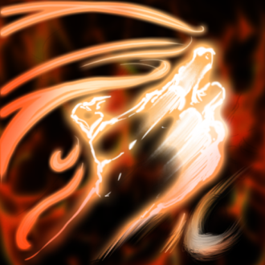
Burning Hands
Fire I
Tactical
Target enemy unit is blasted with heat, taking 4 fire damage (+4 per fire shard). Burning Hands only has a range of 1.
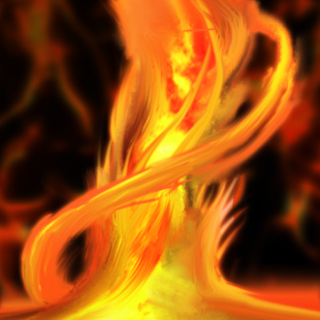
Pillar of Flame
Fire II
Strategic
Target enemy army takes 2 fire damage (+2 per fire shard). Can only be cast within your territory.

Flame Dart
Fire II
Tactical
Does 6 (+4 per fire shard) in fire damage to a single target.

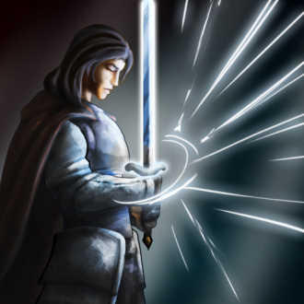
Focus
Fire III
Tactical
Damage is doubled for the casters next action. Focus has a low mana cost.

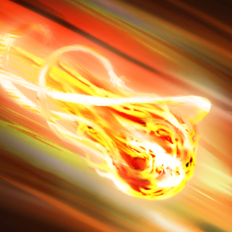
Fireball
Fire III
Tactical
A fireball does 8 (+4 per fire shard) damage to all units within a 1 tile radius. Damage is multiplied by the members of the victims unit.
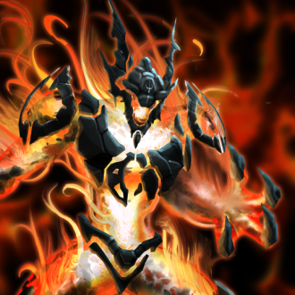
Summon Fire Elemental
Fire IV
Universal
Summons a level 4 (+1 per fire shard) Fire Elemental. If the elemental is summoned into tactical combat it lasts until the end of that combat, if the elemental is summoned from the strategic map it has a maintenance cost.

Mantle of Fire
Fire IV
Strategic enchantment
Wreathes the target in flames, doing 4 fire damage to anyone who attacks him.
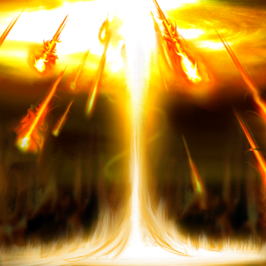
Firestorm
Fire V
Strategic
All units in target army take 12 fire damage (+6 per fire shard). Firestorm leaves a fire raging in the affected tile for 10 turns.


Life Spells
Only Kingdom casters can learn Life spells. Life spells are available to all Kingdom casters who have the required proficiency with Life magic.
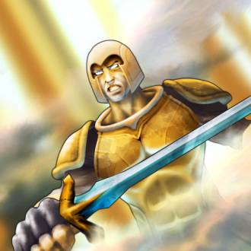
Courage
Life I
Strategic enchantment
Instills legendary hope in the unit, giving them a bonus of 3 (+1 per life shard) to spell resistance and hit points.
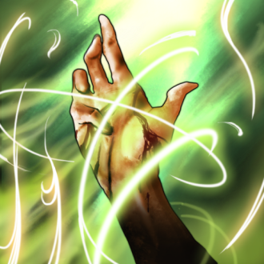
Regeneration
Life I
Strategic enchantment
Regenerates target unit's health by +1 per turn (+1 per life shard).


Aura of Vitality
Life II
Strategic city enchantment
All units produced in this city are +3 constitution (+1 per life shard).

Heal
Life II
Tactical
Heals friendly unit for 8 (+4 per life shard) hit points.

Growth
Life III
Tactical
Target unit gets +50% to Attack and halves their Dodge.


Shrink
Life III
Tactical
Target unit gains +50% to Dodge and their Attack is halved.

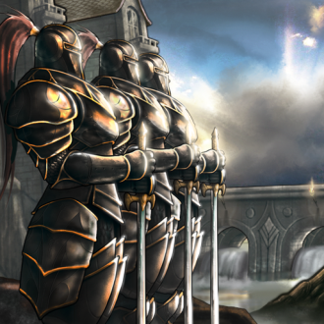
Call to Arms
Life IV
Strategic
First unit in the city queue is instantly trained.


Wellspring
Life IV
Tactical
All allies are healed for 4 hit points (+2 per life shard).
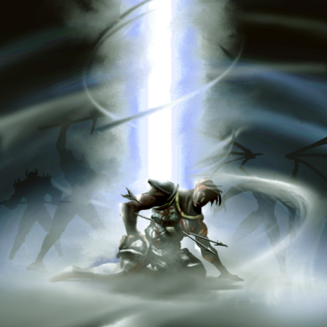
Death Ward
Life V
Strategic enchantment, Targeted hero gains the ability to retreat to the nearest city if they fall during a battle.


Water Spells

Water spells are available to all casters who have the required proficiency with water magic.
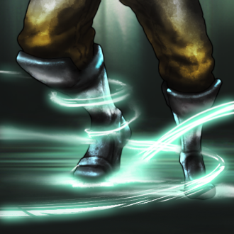
Slow
Water I
Tactical
Target unit suffers -2 (-1 per water shard) to Combat speed.
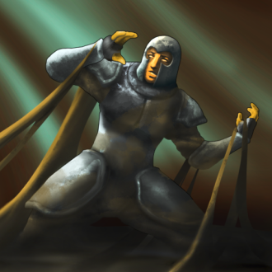
Stinking Mud
Water I
Tactical
Changes the terrain within 1 tile to mud. Units can only move 1 space per turn through mud.

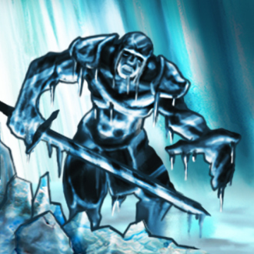
Freeze
Water II
Strategic
Target enemy army is reduced to 1 move per season for 3 seasons. Must be cast within your territory.

Inspiration
Water II
Strategic city enchantment
Cast this spell on your city for a +25% to research, but training units takes 25% longer.
Slow
Water II
Tactical
Target unit suffers -2 (-1 per water shard) to Combat speed.
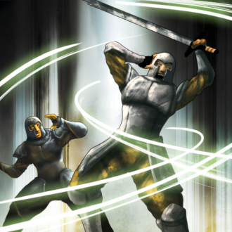
Confusion
Water III
Tactical
Target enemy unit strikes all surrounding allies for half their attack unless they resist.
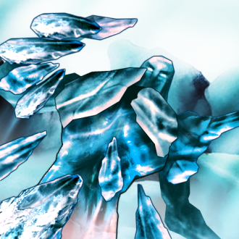
Summon Ice Elemental
Water III
Universal
Summons a level 2 (+1 per ice shard) Ice Elemental. If the elemental is summoned into tactical combat it lasts until the end of that combat, if the elemental is summoned from the strategic map it has a maintenance cost.
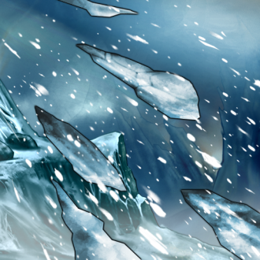
Blizzard
Water IV
Tactical
Assaults target foes with an ice storm, dealing 6 damage, +3 for each Water shard, to each unit in the area of effect. Damage is multiplied by the members of the victims unit.
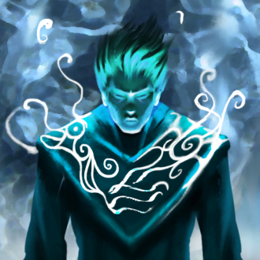
Mantle of Oceans
Water IV
Strategic enchantment
Halves the mana costs of all tactical spells this unit casts. Mantle of Oceans doesn’t have a maintenance cost.
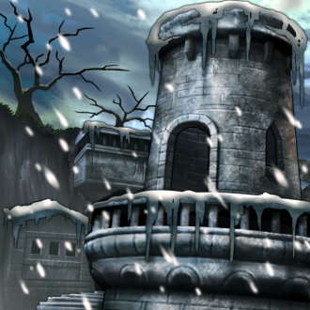
Grip of Winter
Water V
Strategic enchantment
Halts training and construction in target players cities and halves the rate that player gathers resources.


Ceresa’s spell book
These spells are only available to the Empire of Resoln, or custom factions that select the Death worship trait.

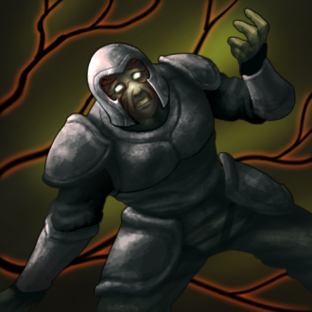
Infection
Death I
Tactical
Each turn target unit's debuffs spread to all allied units.

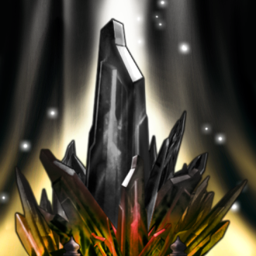
Corruption
Death II
Strategic
Transforms a shard in your territory into a Death shard.


Graveseal
Death III
Tactical
Target unit suffers critical hits from all attacks that hit him unless he resists.

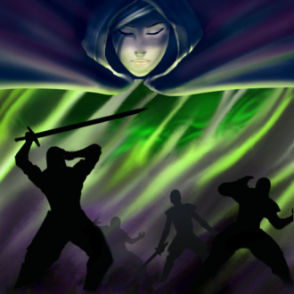
Dirge of Ceresa
Death IV
Tactical
All enemy units take 6 (+3 per death shard) poison damage per member and take 2 poison damage (+1 per death shard) per turn for 10 turns.

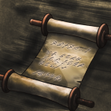
Researched spells
The following spells can only be unlocked be researching the appropriate technologies. Not all of these technologies will be available in every game.

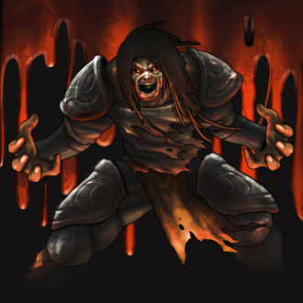
Blood Rage
Immortal Codex
Death IV
Strategic
Enchanted unit gains HP and strength for all damage dealt.


Eyes of the Eagle
Book of Winds
Air I
Strategic
Reveals all areas within 6 tiles of the caster.
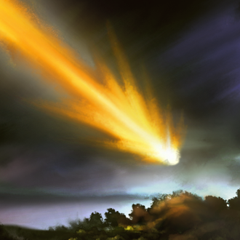
Falling Star
Third Book of the Magi
Air V and Fire V
Strategic
Does 18 fire damage (+9 per air and fire shard) to all armies within 1 tile of the impact point.
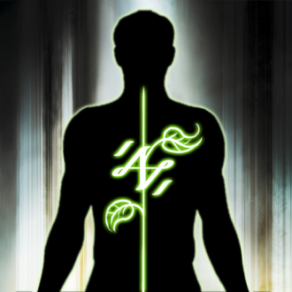
Glyph of Life
Immortal Codex
Life III
Strategic enchantment
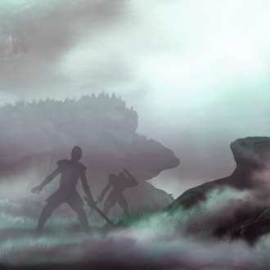
Enchanted unit receives a +10 boost to max hit points (+10 per life shard).
Obscuring Fog
Book of Winds
Air II and Water II
Strategic
Summons a fog that blurs your units and improves their dodge by 3 (+1 per water shard) and an additional 3 (+1 per air shard) vs missile attacks.

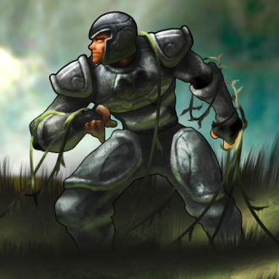
Pull of the Earth
Third Book of the Magi
Earth III
Units within range have their strength halved and are knocked prone unless they resist.
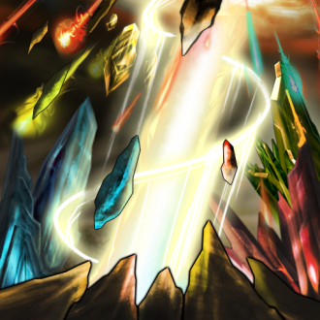
Spell of Making
Book of Mastery
Strategic
This spell places the full power of magic at your disposal, allowing none to challenge your sovereignty. To cast this spell the caster must control an Air, Earth, Fire and Water shard.

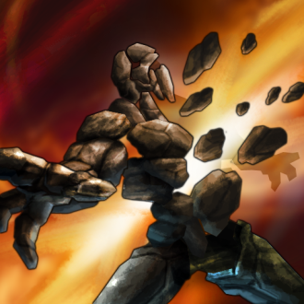
Sunder
Immortal Codex
Earth II and Fire II
Tactical
Target elemental takes 4 damage per level of the caster.

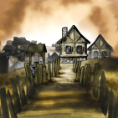
Quest spells
The following spells can only be unlocked by completing quests.

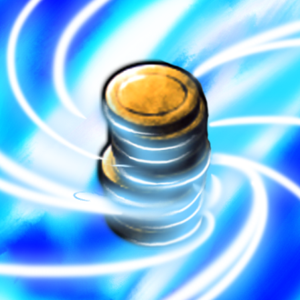
Alchemy
Earth II
Strategic
Convert 25 mana into 25 gildar.


Aura of Might
Earth II
Strategic city enchantment
All units produced in this city are +3 strength (+1 per earth shard).

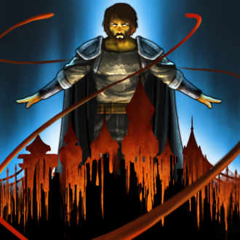
Blood Curse
Death IV
Strategic
Target city sacrifices half its citizens. The caster receives a hit point for each citizen sacrificed. The caster no long heals naturally. Only the sovereign can cast this spell.

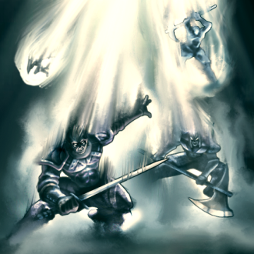
Call of the Titans
Air V
Strategic
All unstationed units will be teleported to the selected tile.


Celerity
Air IV
Tactical
Increases the caster’s Combat Speed by 5 and Dexterity by 50 for this battle. But the strain of accelerating a body this much has its price, the caster's Constitution is permanently reduced by 1.

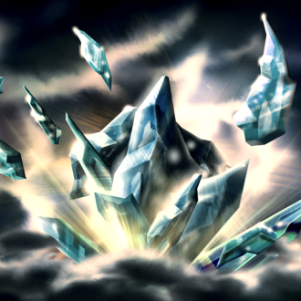
Consume
Strategic
Destroy a shard in your territory to gain 200 mana.

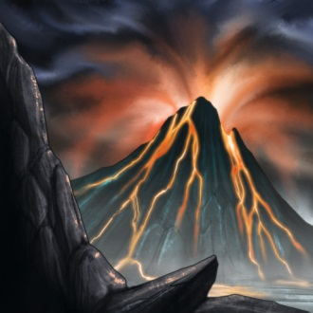
Curgen's Volcano
Earth V and Fire V
Strategic
Raises a volcano in the midst of your enemies. The volcano destroys resources, improvements and even cities on the land it targets.

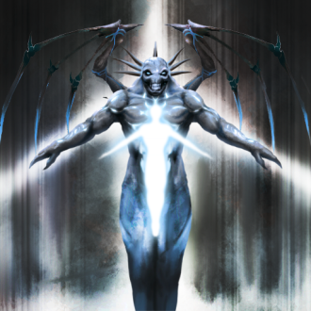
Infernal Covenant
Death IV
Tactical
Sacrifice a champion to transform him into a Death Demon for that battle. The higher level the champion, the more powerful the death demon will be.

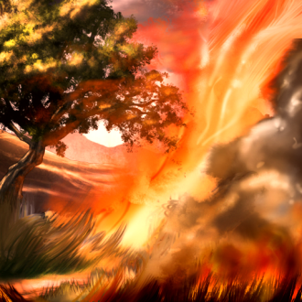
Inferno
Fire II
Universal
Target tile is on fire for 30 turns, walking through the tile causes 5 damage to each member of the group.
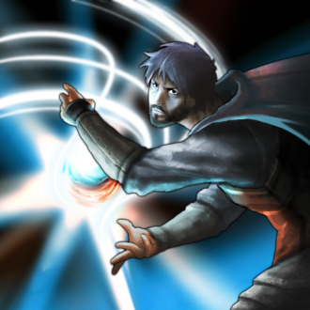
Mana Blast
Fire II and Water II
Tactical
A blast of arcane energy that does damage equal to one tenth the players stored mana.


Mana Shield
Earth IV and Water IV
Strategic
Damage taken by the target is ignored. Instead mana is lost from the mana pool.

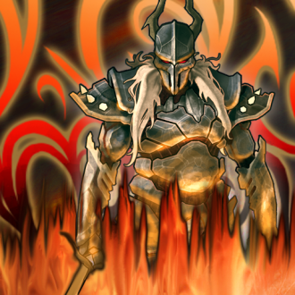
Pariden's Return
Tactical
Summons a Titan from a distant world to fight for five turns.

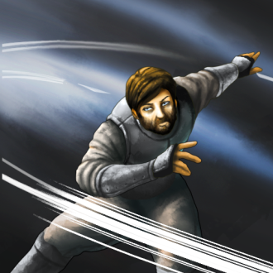
Reprisal
Earth II and Water II
Tactical
All of your units gain the ability to counterattack, and each time they are stuck their defense increased by 1.


Return
Air II
Strategic
Moves the caster (and their army) back to their capital city.

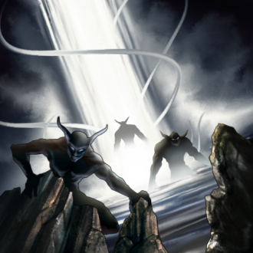
Shadow World
Strategic
Opens a gate to a shadow world. Creatures may come through the portal, though they will be hostile to the caster and his enemies. Shadow World has a high maintenance cost and the portal will remain open until an army destroys it or that maintenance cost isn’t paid.

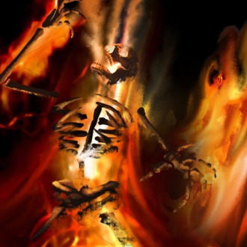
Soulburning
Death III and Fire III
Tactical
Does 5 fire damage (+5 per death and fire shard) to target unit. If the unit is killed an inferno is left in their tile.

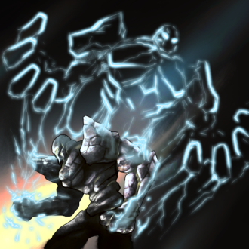
Summoner's Boon
Strategic
Summoned units get a 50% boost to attack.


Touch of Entropy
Death IV
Tactical
Does 12 damage (+6 per death shard) to target unit. If that unit is killed a Lurk is summoned in its place.

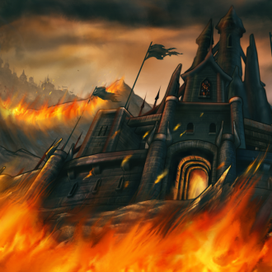
Wall of Fire
Fire III
Strategic city enchantment
Wreaths your city in a protective wall of flames. Enemy units that attack this city take 2 (+2 per fire shard) in fire damage at the start of combat.

